Software Engineering 11–12 (2022): Sample unit of work Year 11
Sample units are provided by NESA to illustrate teaching, learning and assessment of syllabus outcomes and content. Teachers should seek advice from their schools and sectors about local requirements for units of work, including opportunities for reflection and evaluation, and recording evidence of adjustments to meet the needs of individual students with disability.
Unit title: Practical programming in context
Duration: 7–8 weeks
Description: This unit is centred on a programming activity connected to the development of a computerised Sudoku puzzle. Students will have the opportunity to develop an understanding of how software developers plan, design and implement solutions to problems using a structured approach. Essential learning in this unit includes exploring the nature of data and the ways in which computers store and manipulate data to solve problems. In this unit, project work and practical activities support the development of knowledge and its application through skills.
Outcomes | Syllabus requirements
- SE-11-01 describes methods used to plan, develop and engineer software solutions  - SE-11-02 explains how structural elements are used to develop programming code  - SE-11-03 describes how current hardware, software and emerging technologies influence the development of software engineering solutions  - SE-11-04 applies safe and secure practices to collect, use and store data  - SE-11-06 applies tools and resources to design, develop, manage and evaluate software | This unit will make use of the Python programming language for all practical programming learning activities but it may be used in any of the range of available Python integrated development environments (IDEs).  The content is embedded in small and/or medium-sized programming projects.

Unit information

Programming fundamentals
Content

Software development
- Explore fundamental software development steps used by programmers when designing software, including:
- requirements definition
- determining specifications
- design
- development
- integration
- testing and debugging
- installation
- maintenance
- Research and evaluate the prevalence and use of online code collaboration tools

Suggested teaching, learning and assessment activities | Suggested resources
Students are introduced to the stages of software development that are typically used in the Waterfall approach. The Waterfall approach is the most detailed software development approach and allows students to develop an understanding of each of the ‘including’ elements presented in the syllabus.  Students use a template for the development of a software project (Appendix A) to explore the fundamental software development steps used by programmers. Students participate in guided discussion that covers the different stages of software development and consider questions that include:  - What is the relationship between each step in the approach used and the development steps?  - Why is it necessary to test and debug in both the development and maintenance steps?  - In which steps could a designer incorporate the use of online code collaboration tools? | Appendix A  A range of appropriate published case studies.  Note: Case studies should be able to demonstrate activities completed in the steps.
Reflecting on the introductory activity on the software development steps, the teacher discusses with students how some developers use collaboration tools in determining specifications and designing and developing solutions. Students use contemporary sources to research online code collaboration tools and evaluate their use and application of best practice. Students use the following questions to guide their research and build their understanding of how these tools are used by a software engineer to help them develop code and their prevalence among software design teams:
- What is the name or location of the online code collaboration tool?
- How does the tool support collaboration in a software development team?
- How popular is the collaboration tool?
- Is the tool monitored and if so, by whom?
- How is the tool administered?
- How does the tool contribute to the efficiency of managing a software engineering project?
Students record and document the findings from their research in a mode of their choice for use in the development of a folio.

Content

Designing algorithms
- Apply computational thinking and algorithmic design by defining the key features of standard algorithms, including sequence, selection, iteration and identifying data that should be stored
- Apply divide and conquer and backtracking as algorithmic design strategies
- Develop structured algorithms using pseudocode and flowcharts, including the use of subprograms
- Use modelling tools including structure charts, abstraction and refinement diagrams to support top-down and bottom-up design
- Identify procedures and functions in an algorithm
- Analyse the logic and structure of written algorithms, including:
- determining inputs and outputs
- determining the purpose of the algorithm
- desk checking and peer checking
- determining connections of written algorithms to other subroutines or functions
- Experiment with object-oriented programming, imperative, logic and functional programming paradigms

Suggested teaching, learning and assessment activities | Suggested resources
Students use a free online Sudoku puzzle to develop an understanding of the logic associated with decisions made while playing Sudoku. This activity is designed to establish foundational understanding that will contribute towards purposeful algorithm design. The layers of foundational understanding include:  - Has the student ever successfully played Sudoku?  - What does the student already know about playing Sudoku?  - What is the goal of the game?  - What decisions are made during gameplay?  Note: Depending on their coding experience, some students may find the complexity of a  two-dimensional array challenging. A one-dimensional array, such as a jumbled word game, could help build student knowledge and understanding before progressing to the Sudoku activity.  Students use a template for the analysis of Sudoku game strategy (Appendix B). The template provides a sample Sudoku grid with space for students to design algorithms. Students should refer to the Higher School Certificate Course Specifications – Software Engineering for symbols and control structures that could be used in their algorithm design. The development of the algorithms used by Sudoku include:  - decomposition and pattern recognition  - divide and conquer and backtracking  - loops and branching  - connecting the array structure of Sudoku with data storage locations.  Students use this design work to discuss a number of strategies to solve rows, columns and sets of 9 sections of Sudoku. This discussion will form the basis of developing a mainline algorithm and support the skills of designing algorithms for any appropriate subroutines.  Students develop their skills and perform a desk check of their solution(s) for the Sudoku puzzle solver using appropriate test data, including out-of-range and unexpected datasets. During this activity, students draw connections with the research conducted in earlier lessons associated with online code collaboration tools. Questions for consideration include:  - What algorithm structures have other designers used for the mainline or subroutines used for published online Sudoku games?  - What are the most common standard algorithm structures other designers have used? Why?  Students design, develop and present their algorithms in line with the possible methods presented in earlier lessons where they learnt the modes used to design software engineering solutions. | Appendix B: Sudoku grid template  Higher School Certificate Course Specifications – Software Engineering  https://curriculum.nsw.edu.au/learning-areas/tas/software-engineering-11-12-2022?tab=assessment#software-engineering-hsc-examination-specifications-software_engineering_11_12_2022
Students develop their skills by experimenting with different programming paradigms to translate algorithms into programming code. Students use a range of online tutorials, with options including Python, Basic, JavaScript and Prolog, to create simple programs. This can support understanding of how different languages are used to construct the common algorithmic structures determined in the previous activity for the Sudoku game. Simple algorithms need not be complex coding but may involve an everyday task, like baking a cake.  Students develop a comparative report between the paradigms and present the findings using a mode of their choice. | freeCodeCamp  https://www.freecodecamp.org/news/an-introduction-to-programming-paradigms/

Content

Data for software engineering
- Investigate the use of number systems for computing purposes, including binary, decimal and hexadecimal
- Represent integers using two’s complement
- Investigate standard data types, including:
- char (character) and string
- Boolean
- real
- single precision floating point
- integer
- date and time
- Create data dictionaries as a tool to describe data and data types, structure data and record relationships
- Use data structures of arrays, records, trees and sequential files.

Suggested teaching, learning and assessment activities | Suggested resources
Using direct teacher instruction, students develop an understanding of common number systems, including binary, decimal and hexadecimal, and learn about calculating each. This knowledge supports a student’s understanding of how programming code uses data and of character representation in ASCII or Unicode. Students develop the knowledge that any code they write needs to be processed by a computer and therefore needs to be converted into ones and zeros to work.  Students use the Higher School Certificate Course Specifications – Software Engineering to determine the importance of ASCII and Unicode in the development of software engineering solutions. | Higher School Certificate Course Specifications – Software Engineering  https://curriculum.nsw.edu.au/learning-areas/tas/software-engineering-11-12-2022?tab=assessment#software-engineering-hsc-examination-specifications-software_engineering_11_12_2022
Students use the knowledge developed in previous lessons to focus on the use of Python to develop the solution for programming a Sudoku puzzle. The teacher provides direct instruction for students to investigate the range of data types and structures available in the Python programming language. Students engage in a range of tutorials that use specified data types in Python. Tutorials should exercise the use of:  - character and string  - Boolean  - real  - single precision floating point  - integer  - date and time.  As students develop an understanding of how data is represented in Python, they draw on knowledge from previous lessons and activities to develop an appropriate data dictionary that includes data types, structures and relationships for the Sudoku puzzle. Details of the layout of a data dictionary can be found in the Higher School Certificate Course Specifications – Software Engineering. Students should use the layout presented in this document. | W3 Schools  https://www.w3schools.com/python/  Python.org  https://wiki.python.org/moin/BeginnersGuide/Programmers  Higher School Certificate Course Specifications – Software Engineering  https://curriculum.nsw.edu.au/learning-areas/tas/software-engineering-11-12-2022?tab=assessment#software-engineering-hsc-examination-specifications-software_engineering_11_12_2022

Content

Developing solutions with code
- Apply skills in computational thinking and programming to develop a software solution, including:
- converting an algorithm into code
- using control structures
- using data structures
- using standard modules
- creating relevant subprograms that incorporate parameter passing
- Implement data structures that support data storage, including:
- single and multidimensional arrays
- lists
- trees
- stacks
- hash tables
- Use debugging tools, including:
- breakpoints
- single line stepping
- watches
- interfaces between functions
- debugging output statements
- debugging software available in an integrated development environment (IDE)
- Test and evaluate solutions, considering key aspects including functionality, performance, readability of code, quality of documentation
- Determine typical errors experienced when developing code, including syntax, logic and runtime, and explain their likely causes

Suggested teaching, learning and assessment activities | Suggested resources
Students apply the knowledge, understanding and skills developed in previous lessons to start their first independent programming activity. A range of support tools facilitates independent programming, including:  - scaffolds to meet different student needs, abilities and prior knowledge  - selected code fragments or pre-developed, coded subroutines to ensure the success of the final solution  - building a solution as a team to support student success, where students have to develop a smaller fragment of the whole solution.  Note: The final compiled solution is developed using Python and includes subroutines with appropriate data passing.  During the development phase students engage in broader discussions which allow them to compare different data structures to make decisions about their use in programming their solution. Discussion pieces that support a student’s understanding of the previous lessons and activities include investigating by testing the applicability of an array, a list, tree, stack and/or hash table in solving the Sudoku puzzle. | A range of online resources that explain and provide examples of Python data structures, include:  - Lists  - Sets  - Tuples  Possible IDEs could include:  - Repl.it  - Pycharm  - Spyder
The processes associated with the testing phase of engineering software solutions develops key foundational knowledge, understanding and skills. Students evaluate their own solution and review and evaluate the solutions developed by other students.  Students then use debugging tools. Python IDEs may have different debugging tools so it may be necessary to use more than one IDE or tool to address syllabus content. The debugging process should allow students to evaluate through debugging output statements and check for:  - breakpoints  - single line stepping  - watches  - interfaces between functions.  In earlier lessons and activities, the types and boundaries of test data were determined when designing and testing algorithms. This data should be used here.  Students record and document any errors during the debugging process. Classifying these errors is an important foundational skill. Common errors students may encounter include:  - syntax  - logic  - runtime.  Recognising, classifying and documenting these appropriately will enhance a student’s ability to desk check, trace algorithms and review code for errors and build a glossary of solutions for programming bugs.  Students complete a full debugging process before presenting their solution for other students to evaluate.  When desk checking their own solution and the solutions of their peers, students begin by assessing the functionality and performance of the final Sudoku game. This can be done by playing their own and other student solutions and providing feedback. A guide to the components that students could evaluate include:  - Is the game easy to navigate, start and play?  - Does the game provide any instructions or feedback?  - How attractive is the interface?  Note: While these are not the primary purposes for the development of the Sudoku solution, it previews items that students will consider in future lessons as they progress through the Year 11 content of the Software Engineering 11–12 Syllabus. | The range of Python IDEs may use different debugging tools, so it may be necessary to use more than one IDE or tool to address syllabus content.

Reflection and evaluation (Space for teachers to reflect on and evaluate the unit)

Appendix A

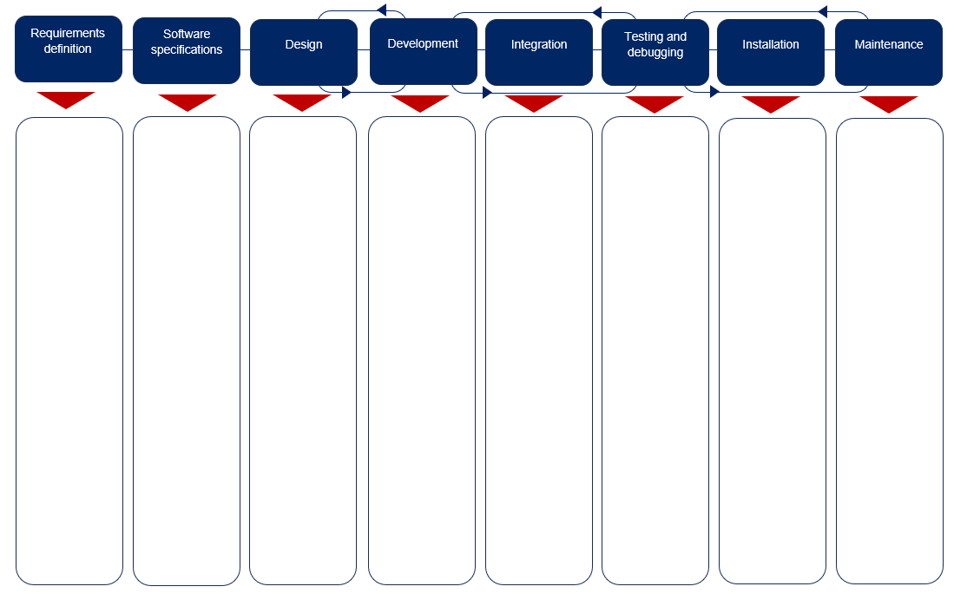
Scaffold for the development of software projects
Use this box to detail the scope for maintaining the solution.
Use this box when the software solution requires specific installation rules. This box may contain a generic statement indicating the solution does not require installation.
Use this box to list the IDEs and debugging tools to be used including any test data.
Use this box if the software solution is to be integrated with another solution or a specific operating system. This box may contain a generic statement if integration is not required.
Use this box to list the elements that will require development and the modules or code fragments that may be re-used from other projects or libraries.
Use this box to list the elements that will require designing.
Use this box to list the specifications for the software solution.
Use this box to list the overall requirements for the software solution.

Appendix B

Template for the analysis of Sudoku game strategy

Sample starting grid
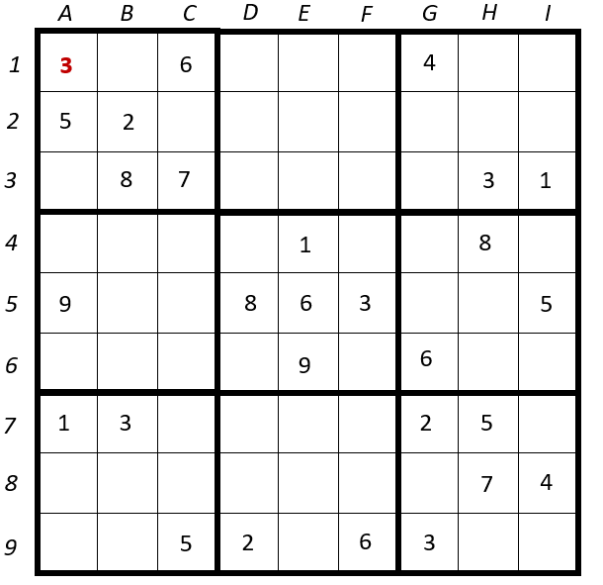
Develop your algorithm in this space using the symbols and control structures outlined in the Higher School Certificate Course Specifications for Software Engineering. You may use Pseudocode or Flowcharts to represent your algorithm. Start at the red ‘3’ [1,A].

Appendix B (Alternate)

Template for the analysis of Word Jumble game strategy

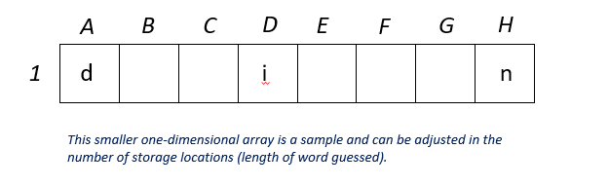
Sample starting grid
Develop your algorithm in this space using the symbols and control structures outlined in the Higher School Certificate Course Specifications for Software Engineering. You may use Pseudocode or Flowcharts to represent your algorithm. Start at the red ‘3’ [1,A].

